Biological Evaluation of the New Lamprey Orifices Installed In the Tilting Weir Section of the Oregon Shore Fishway at McNary Dam.

COE DRAFT Monitoring and Salmon Protection Plan

Background:
Dewatered ladder inspections have documented potential adult lamprey passage problem locations in the tilting weir section of the Oregon shore fishway at McNary Dam. Salmon orifices built into the tilting weirs are not located on the fishway floor (orifices can be up to several feet above the fishway floor) and likely create passage problems for migrating adult lamprey. Data from recent radio telemetry studies at McNary Dam indicate that the tilting weir section is a location that causes delay and may pose a passage problem for lamprey. As a result of these observations, the Walla Walla District Corps of Engineers is planning to make some modifications to the Oregon shore fish ladder at McNary dam with the intent of improving upstream lamprey passage (reduce delay and increase ladder passage success). Modifications are planned in the tilting weir section of the upper Oregon shore fish ladder where a total of nine stem walls that support the tilting weirs will be modified to include lamprey orifices; two orifices per stem wall totaling 18 orifices.

Purpose:
The purpose of this monitoring plan is to evaluate the effectiveness of lamprey orifices to aide lamprey passage through titling weir segment of the McNary Dam Oregon-shore fishway while ensuring that these new lamprey orifices do not delay or harm migrating salmon and steelhead. Salmon and steelhead may attempt to pass or delay as a result of attraction to water flow through these new orifices (which are intended for lamprey passage only). Information is lacking on how lamprey pass through high velocity environments and observations of how lamprey behave and perform passing these structures may be useful addressing similar situations at other locations.

Lamprey Orifice Design:

The concrete will be cut out of the stem walls 12” offset from the fish ladder walls, flush with the floor. The Lamprey orifices will be lined with steel inserts which will be grouted in place. Lamprey orifice dimensions will be 3 inches tall by 18 inches wide, will have rounded edges (4 inch radius) on the sides and the top of the orifice and will be flush with the floor of the ladder (Figure 1 and 2). The floor of the orifice will be smoothed to aid in Lamprey attachment for passage through these structures.

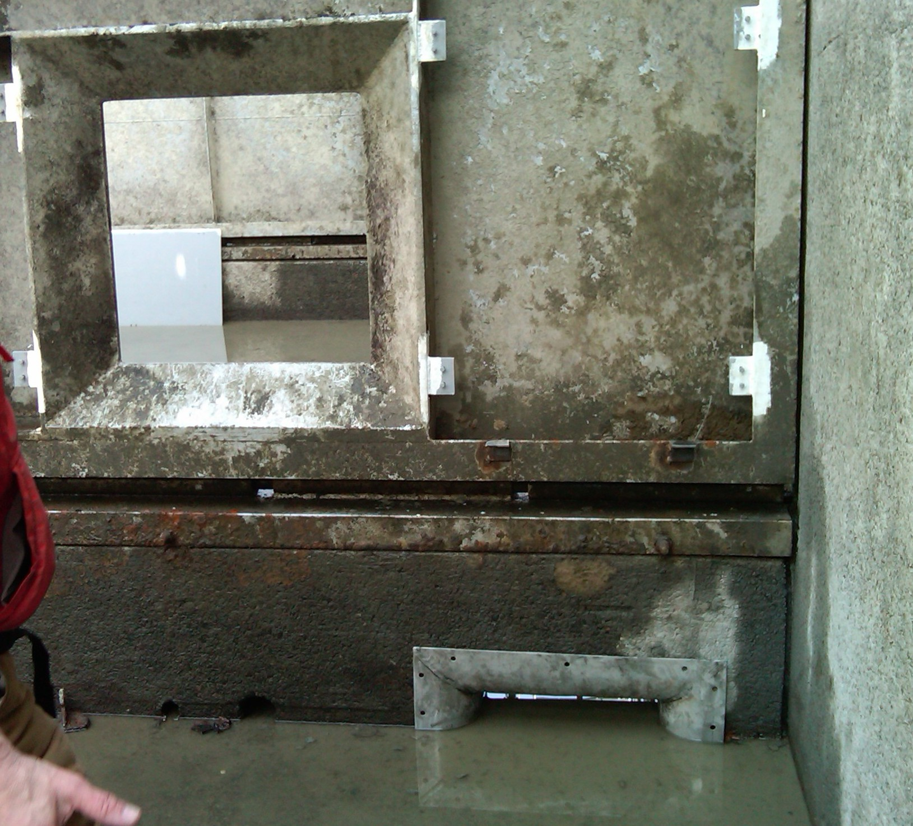
Figure1. Lamprey orifice (bottom right). Note location and size relative to larger salmon orifice (upper left).

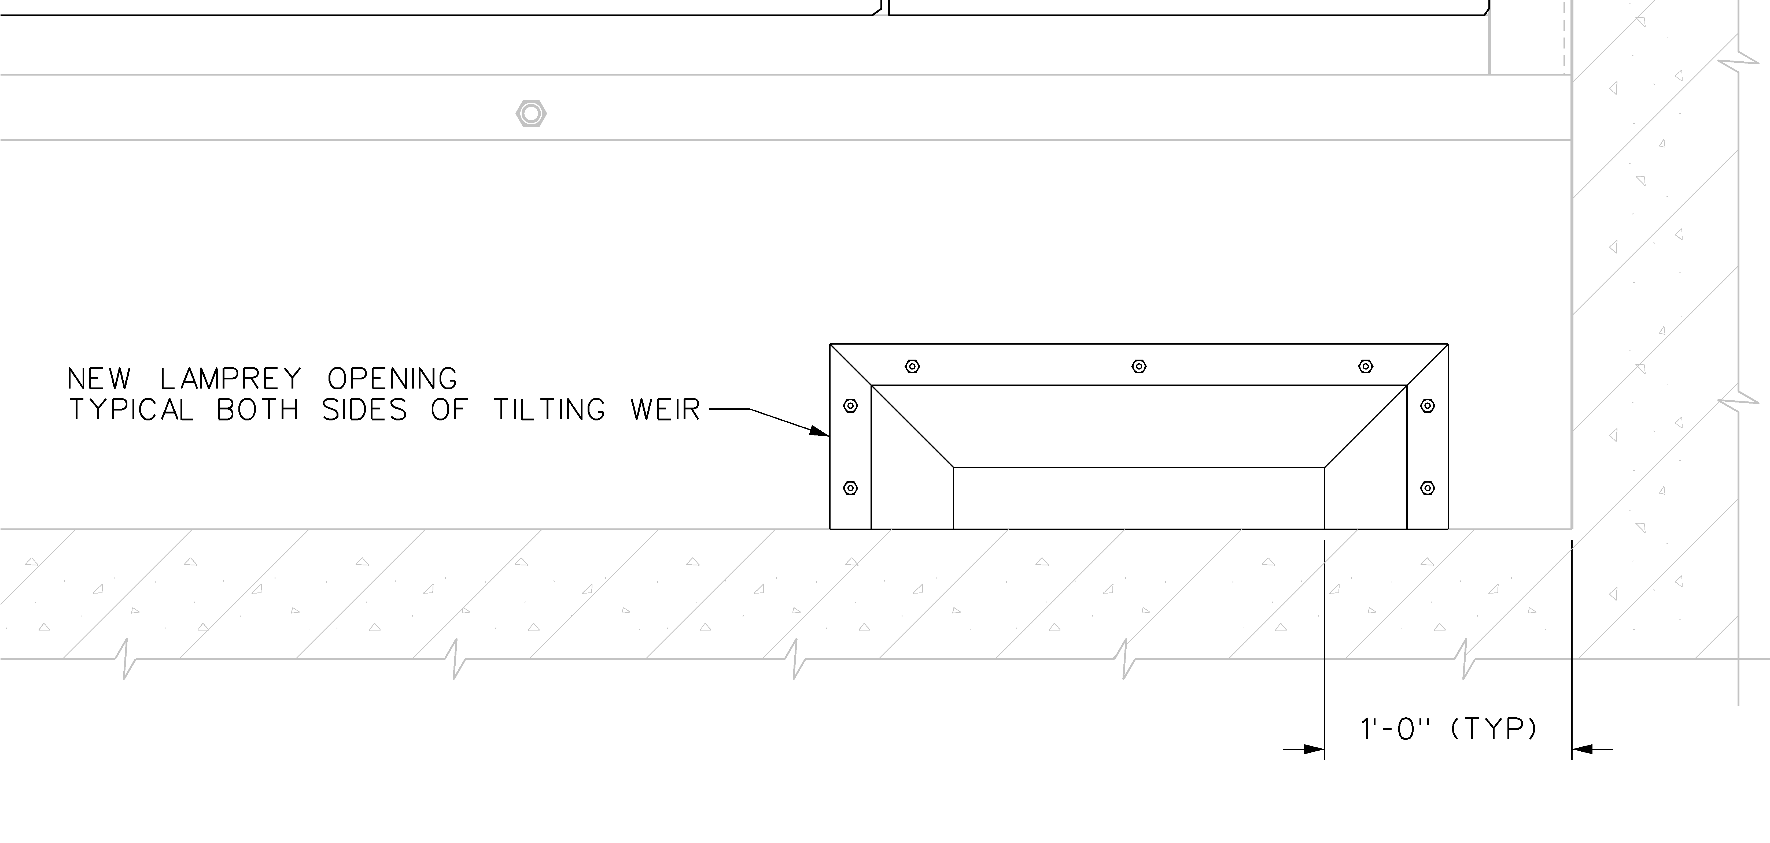
Figure 2. Lamprey orifice elevation drawing.
Figure 3. Lamprey orifice exit and orifice gate closure device.

Salmon Protection Plan
All lamprey orifices will have an orifice gate closure device (Figure 3) installed so the lamprey orifices can be opened and closed without ladder dewatering. Following final construction of the orifices, lamprey orifice gates will be closed except at weirs 335 and 336. Lamprey orifices at weirs 335 and 336 will remain open and will be monitored with underwater video cameras. These four lamprey orifices will be closely monitored during the spring, summer and fall salmon and steelhead seasons to determine the effects on lamprey orifices on salmon passage behavior via underwater video (detailed below). If lamprey orifices show no impact to spring and early summer run-salmon, the goal is to have all lamprey orifices operating as the lamprey run begins at McNary Dam in late June or Early July 2010.

In the event of some unforeseen problems or issues associated with closing the lamprey orifice gates, a partial shutdown and dewatering of the upper fish ladder may be needed to manually close the lamprey orifice gates.

Salmon Protection Criteria for Closing of Lamprey Orifices based on Video Observations:

DRAFT Criteria: Criteria to be further discussed at FPOM and/or FFDRWG.

Currently there are no indications that adult salmon and steelhead experience difficulty transiting the tilting weir section of the south-sore fishway and in general most salmon appear to prefer to use submerged orifices to ascend fishways. There is a concern that addition of lamprey orifices may diminish salmon passage by creating confusing hydraulic conditions or by attracting fish to the small orifices and thus delaying passage through the modified ladder. There may be three types of salmon behavior associated within the location and in the vicinity of the lamprey orifices.

- Holding/Resting behavior as fish pass from pool to pool in the fishway
  - Fish are holding / resting in the vicinity of the lamprey orifice or confused by modified hydraulic conditions occurring in pool area with no attempted passage or attraction.
- Lamprey orifice investigation behavior by adult salmonids.
  - Adult salmon investigate attractive flow coming through the orifice which may result in 2 options:
    - Salmon attempt to pass the orifice
    - Salmon investigate the flow and do not attempt to pass

- Attempted lamprey orifice passage
  - Adult salmonids are attracted to and attempt to pass the lamprey orifices.

Video observations will be summarized and described as holding, investigation with or without attempted passage, or attempted passage and summary statistics will be provided for discussion. Summary statistics will include estimated % daily, weekly and monthly run affected for each species/run across the season (from April-early October).

Monitoring and Evaluation Plan:

Focused underwater video and opportunistic monitoring of spring Chinook salmon radio tagged at Bonneville Dam for a separate study will be used to evaluate lamprey orifices at McNary Dam.

Video Monitoring Plan: Video monitoring will be used to determine if salmon and steelhead attempt to pass the lamprey orifices or are attracted to and thus delay passage or incur injury as a result of attempted passage.

Intensity of video monitoring will be based on the fish runs at McNary Dam with the highest intensity focused on the following factors:
- Early portion of the spring Chinook salmon run
- Peak of the spring Chinook salmon run
- Early portion of the summer Chinook salmon run
- Peak porting of the summer Chinook salmon run
- Early portion of the Fall Chinook run
- Peak portion of the Fall Chinook run
- Early portion of the Steelhead run
- Peak porting of the Steelhead run
- During times of shad passage and salmon and steelhead passage (during times of mixed species runs)
- During the early, middle, and late lamprey runs (focuses on the peak lamprey run).

The plan is to:

1.) Utilize underwater video cameras to monitoring the first 2 modified stem walls (4 lamprey orifices) and associated tilting weirs at McNary Dam.

a. Video monitoring both lamprey orifice entrances on the first modified weir (weir 335) that salmon, steelhead and lamprey will encounter as these fishes migrate up the ladder. Two underwater video cameras will be installed downstream of the weir to monitor these two orifices.

b. Video monitoring both lamprey orifice entrances on the second modified weir (weir 336) that salmon, steelhead and lamprey will encounter as these fishes migrate up the ladder. Two underwater video cameras will be installed to monitor these two orifices.

Video observations will be made available as near real time as possible to be able to disseminate information to fish managers as quickly as possible. We anticipate turn around of summarized video and statistics to be approximately 24-36 hours. Video cameras types and placement within the fishway will allow for video recording without harm to migrating salmon. Camera types and manufactures will be further investigated. Cameras will be purchased that can gather video at night and daytime lighting conditions. Market research indicates there are newer cameras available that can film under very low light conditions (10-4 lux) without light sources. Video cables and hardware will be mounted in a manner so as to not impede fish passage or cause harm to migrating fish; placement of camera power supply and associated cable will be coordinated with FPOM.

Radio Telemetry & PIT Tag Monitoring Plan:

1. Six hundred spring Chinook salmon will be radio tagged at Bonneville Dam for a separate study. Approximately 2/3, or about 400, of these tagged fish will likely pass McNary Dam. Both fish ladders at McNary Dam will be wired with RT antennas to detect fish as they pass the dam. Passage metrics for both ladders will include numbers of fish that approach, number that approach and enter a ladder, entrance efficiency, numbers of fish that enter and exit the ladder, and numbers that approach a ladder and exit the ladder. The tilting weir section of the south ladder will be monitored to estimate numbers of fish approaching the tilting weir section, numbers of fish passing the tilting weir section, and tilting weir section passage times. Passage metrics will be compared to previous years radio telemetry data ( to the extent possible) to evaluate if salmon and have longer total passage times at McNary Dam in 2010 compared to previous years of monitoring. This will be a gross evaluation on if the lamprey orifices have a measurable effect on salmon passage. This analysis will be conducted in the fall of 2010 after the fish passage season. A summary report of this information will be provided to the salmon managers and data will be presented at the AFEP annual research review in December in Portland, Oregon.

2. Radio Telemetry and Half-Duplex PIT tag monitoring adult lamprey at McNary Dam.

The primary objective of this project is to collect, Half-Duplex PIT tag, and radio tag adult lamprey attempting to pass McNary and Ice Harbor Dams and monitor their passage under current operational conditions. The second objective of this study is to identify locations that restrict lamprey passage and identify potential locations for installing Lamprey Auxiliary Bypass Structures (LAPS; being developed at Bonneville Dam) to aid dam passage for adult lamprey. Information collected from this objective will also be used to evaluate the effectiveness of the new lamprey orifices by comparing passage performance in 2010 to data collected for the tilting weir section at McNary Dam from previous years.

Research Objectives:
A.) Collect and tag (HD PIT and RT) sufficient numbers of adult lamprey to obtain passage success metrics for McNary and Ice Harbor Dams.

B.) Utilize HD-PIT and Radio Telemetry to determine passage problem locations within the fishways at McNary and Ice Harbor Dams and identify potential locations for installation of Lamprey Auxiliary Bypass Structures and for additional fishway improvements.

C.) Identify passage problem locations within the fishways at McNary and Ice Harbor Dams to aid the Corps in making fishway modifications and improvements for adult lamprey.

D.) Determine if the new lamprey orifices installed at the tilting weir section of the south shore ladder at McNary Dam has improved passage times for RT and PIT tagged adult Lamprey.

This research is a separate study under the AFEP program and will be used to help determine if the lamprey ladder changes made in the winter of 2009-2010 have improved lamprey passage conditions.

